S.E.D.O.M - L.L.B Report
September 28, 2026
To: Lay Leadership Board
Date: September 28, 2026
From: Michael, Senior Executive Director of Ministries
Subject: SEDOM REPORT
To: Lay Leadership Board From: Michael, Senior Executive Director of Ministries Date: July 2026 Subject: Monthly Ministry & Strategic Planning Update

1. Presentation of Organizational Chart
I am deeply grateful for our Organizational Structure Committee, whose thoughtful work, prayerful discernment, and steady collaboration have strengthened Christ Lincoln’s ability to serve with clarity and purpose. Their commitment to listening well, asking wise questions, and seeking what best supports our mission has been a true gift. I also want to express special appreciation to Pastor Daniel Potts, whose exceptional skill in diagramming and guiding us through multiple organizational chart options brought clarity to complex decisions. His patience, insight, and partnership have blessed this process and our entire ministry team.

2. Making Room Update

3. Word of Life Lutheran Church 200 Fletcher Avenue, Lincoln, NE (https://wordoflifelincoln.org/)

4. Yankee Hill Capital Campaign: “Growing Forward”
The Yankee Hill campaign continues progressing through early‑stage planning.
- The Growing Forward leadership guide outlines the purpose, rationale, and early alignment needed for Christ Lincoln – Yankee Hill’s upcoming capital campaign. The campaign centers on three priorities—retiring remaining debt, adding parking capacity, and making targeted space improvements—all framed as faithful stewardship responses to sustained congregational growth.

5. Call Process – Sumner 211 Campus Pastor
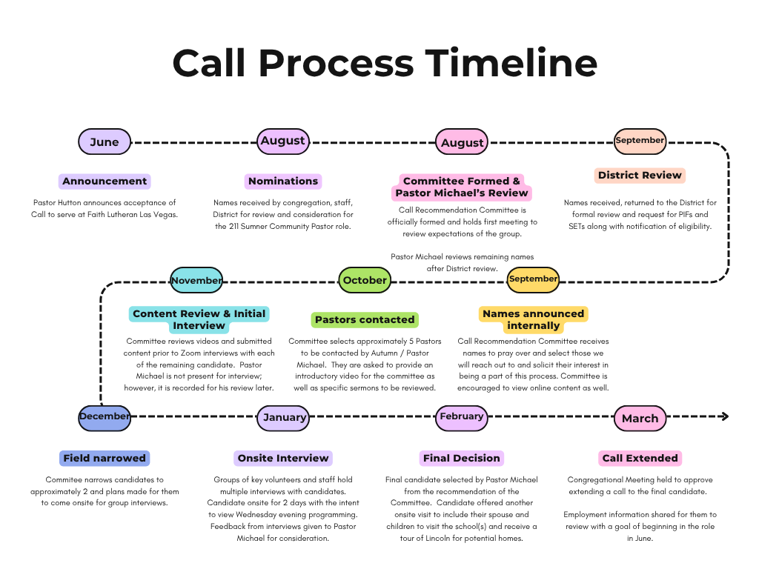
The call process continues moving forward with clarity and unity. (See attached) Current work includes:
- Tara Paulison
- Ted Retzlaff
- Tim Geisert
- Kathy L'Hereux
- Tracy Thelan
- Ryan Dale
- Josiah Janke
- Grace Fahlson

6. Update on “Director” of Finance
- Combine Finance Role with C.A.O Role
- Developing a position description
- Internal/External Search
- FOC Support
- Establishing interim financial coverage
- Preparing interview and evaluation process

7. When Will Half the LCMS Be Gone? The Data Is Alarming | Voices of the LCMS | Episode 21
Overview
The Lutheran Church-Missouri Synod (LCMS) is experiencing a significant demographic shift marked by an aging membership, declining birth rates, and reduced retention among younger generations. These trends create a predictable and accelerating decline that will shape congregational life, pastoral supply, financial capacity, and mission strategy over the next 20-30 years.
Summary Statement
The LCMS faces a demographic tipping point. The next 20-30 years will require courageous leadership, strategic clarity, and deep trust in Christ. While the data is sobering, it also presents an opportunity: to refocus on mission, strengthen discipleship, and invest intentionally in the next generation.
________________________________________
Key Demographic Realities
1. Aging Membership
• LCMS members are among the oldest of any major Christian denomination in the U.S.
• A large percentage of active members are over age 60.
• Younger generations (Millennials and Gen Z) represent a small portion of LCMS membership.
2. Low Replacement Rate
• LCMS families have fewer children than previous generations.
• Baptisms and confirmations have declined steadily for decades.
• Congregations are not retaining or attracting younger adults at replacement levels.
3. Predictable Decline Curve
• As older members age out, the LCMS will experience a steep drop in membership.
• Current data suggests the LCMS could lose half its membership within 20-30 years if trends continue.
• This is not driven by theology or worship style but by demographic mathematics.
________________________________________

Implications for Congregations and the Synod
1. Pastoral Supply Challenges
• Fewer young adults mean fewer future pastors.
• Seminary enrollment reflects the broader demographic decline.
2. Financial and Volunteer Strain
• Aging congregations have fewer volunteers and reduced long-term giving capacity.
• Multi-campus and multi-ministry models may become harder to sustain.
3. Strategic Pressure
• Congregations must make decisions based on realistic timelines.
• Long-term planning must account for shrinking membership and shifting community needs.
________________________________________

Opportunities for Mission and Renewal
1. Focus on Younger Generations
• Prioritize ministry to children, youth, and young adults.
• Invest in relational discipleship and family ministry.
2. Courageous Adaptation
• Evaluate ministry models with honesty and hope.
• Embrace collaborative leadership across congregations and circuits.
3. Gospel-Centered Clarity
• Keep Word and Sacrament ministry at the center.
• Lead with humility, courage, and trust in Christ’s promise to build His Church.

