
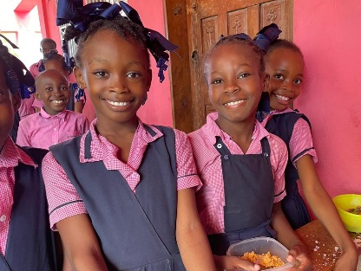

News from Trinity HOPE
This is one of a series of articles which we make available each month to keep our supporters informed about our activities. Trinity HOPE, a not-for-profit charitable organization, raises funds and administers feeding programs that provide a noon meal for the hungry children who attend our schools in Haiti where the Good News of Jesus is shared daily.

************************************************************************************************************
P.O. Box 2910, Lebanon, TN 37088 admin@trinityhope.org (615) 394-4950
Web Page: www.TrinityHope.org Facebook: trinityhopehaiti
**************************************************************************************************

What Does “Back to School” Mean?
By Jay Brinkmeyer
“Cast your burden on the LORD, and He will sustain you; He will never permit the righteous to be moved.” Psalm 55:22, ESV

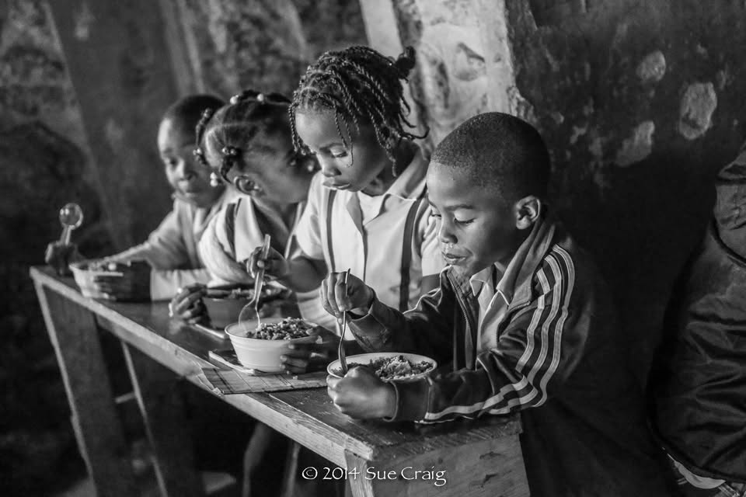
Back in the day, when you were in elementary school, were your class photos in black and white? Mine were. Were you jumping for joy when you were told it was time to get new clothes for school? I wasn’t. After eating home-cooked meals all summer, were you excited to go back to eating school food? It wasn’t high on my list.

The 4 Haitian children in this photo have a very different reason to be excited about going back to school. They are excited about the confidence of a new meal.

Take a closer look at that black-and-white photo. The 4 children are sitting at their desks in a building that is about the same temperature inside as it is outside. They are eating a hot meal of beans and rice, most likely their only substantial meal of the day, using spoons they brought from home. During my time in Haiti, I saw siblings sometimes share the same spoon as they sat next to each other enjoying their meal.

During my visits, I’ve been blessed to spend time in many Haitian schools, and none of them had yearbooks filled with individual and class photographs. Many of the children wear hand-me-down uniforms and shoes. During the summer, when school is not in session, food can be especially scarce.

So, yes, these children are happy to go back to school. They are returning to their classrooms, their friends, and a hot lunch provided through Trinity HOPE.

Thankfully, when they return, the fire under the cooking pot will be burning again.
We serve an incredibly awesome God.

As another school year begins, imagine the joy on the faces of children sitting down to that plate of food, the warmth in their hearts, and the sincere thankfulness in their mealtime prayers. Through the generosity of people like you, children are being fed, prayed with, and reminded that God has not forgotten them.

They place their trust in God. We place our trust in Him, too.

Thank you for going back to school with them. Ain’t God Good?

